


God’s blessings and hope for you from your Lutheran Media team. Thanks for your support. Please use whatever information you like below in your bulletins and newsletters, or even on your PowerPoint information slides at the start or end of service.


Listen to Messages of Hope and invite others to do the same. Download or listen online at www.messagesofhope.org.au, (www.messagesofhope.org.nz for New Zealand audiences).

4th August Lost in a Black Hole (Reverend Noel Due)
Have you ever felt trapped in your own thoughts and feelings, regrets and failings? It can be a lonely place. It can feel like you’re sinking in a black hole with no way out. Noel Due encourages us that there is a way out. Jesus has taken all of our shame to the cross and dealt with it there.

11th August Science or Faith? (Interview)
“God’s not against science. In the same way I don’t think scientists should be ignorant of faith.”
It’s often said that politics and religion don’t mix. Another version of that equation is that science and faith don’t mix. Dr Graham Buxton talks about the relationship between science and faith and asks can we have faith in science, and faith in God?

18th August When Dreams Break (Interview)
“I just felt like a bit of a fool like because I had this happy life one day and the next day it had all fallen to bits” Where do you go when your dreams are shattered? How do you grieve? How do you risk dreaming again?
Listen to Deborah’s story and how she found hope to dream again

25th August Joy Beyond Shattered Dreams (Reverend Noel Due)
“God isn’t a cruel trickster. He hasn’t left us in a dark box with a jigsaw puzzle to assemble without a torch.”
Have you ever felt stuck in the dark, with no way out? Life may be dark because you’ve lost your job, or someone you love. Noel Due shares how God does offer us a torch, and how to discover a way through the dark times.

SHORT MOVIE COMPETITION


Do you like making short movies? Or know someone who does?
Enter the Lutheran Media Short Movie Competition with a movie under 4 minutes long that shares a story or theme of Christmas or Easter. Enter as an individual or as a group.
The best videos to be shared through social media and the internet.
Cash prizes for the best short movies and entries receive a Lutheran Media gift pack.
Entries close on the 10th September 2019.
Go to www.lutheranmedia.org.au/competition for more information and entry details.


What’s happening on our YouTube channel

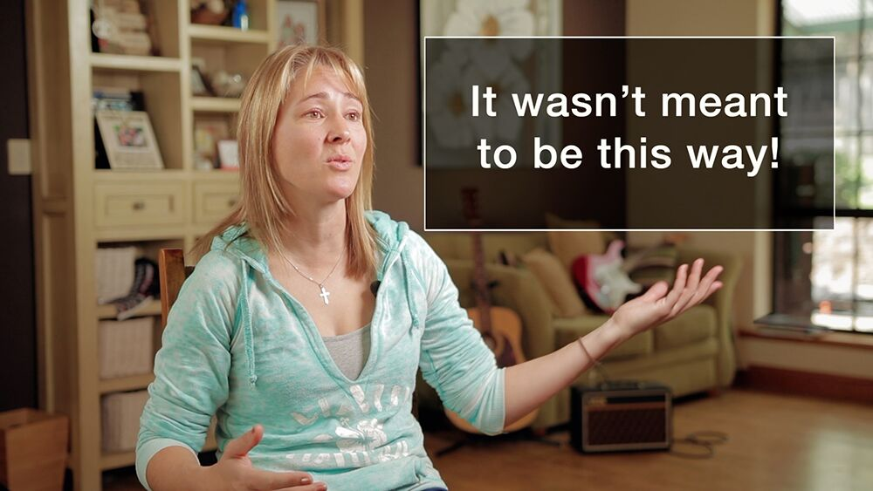
Do you sometimes feel like this is not what I signed up for? Like you’re running around flat out, but not really getting anywhere?
Lutheran Media is excited to share with you our new short film “When reality crashes into dreams. It’s the story of a young mum sharing her struggle through stress.”
Click here to watch https://youtu.be/X45hIOxufro
Share the link with anyone you think might be interested. Together we can get our messages of hope out to as many people as possible.

Check out the latest inspiring videos on our YouTube. There are 1 minute messages that you can download and play before or after your services www.youtube.com/messagesofhope

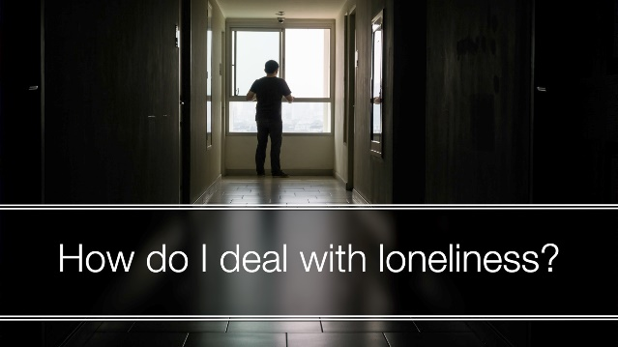

JOIN OUR FACEBOOK COMMUNITY AT:
www.facebook.com/messageshope
www.facebook.com/lutheranmedia
www.facebook.com/happyland4kids
www.facebook.com/messagesofhopenz
 Follow us on Twitter at @lutheranmedia, @messagesofhope1 and @messagesofhopenz
 Follow us on Instagram @luthmedia, @messagesofhope1

FAMILY FUN AT HAPPYLAND.COM.AU
Enjoy the Happyland website game at www.happyland.com.au. Set up your own character, change them, and take them on an adventure. Go on to the App store and download the Happyland App for iphone and ipad.
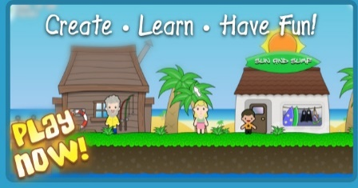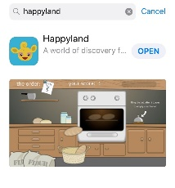
ONLINE LIVE STREAMED WORSHIP
Worship with the St Michael’s Lutheran Church, Hahndorf, SA or Good Shepherd Lutheran Church, Toowoomba, Qld at www.livestream.com/luthworship
FREE WORSHIP SERVICE DVDs
Can’t attend church? Order your FREE worship DVD/CD by contacting Lutheran Media. FREECALL 1800 353 350 or email us luthmedia@lca.org.au

