


God’s blessings and hope for you from your Lutheran Media team. Thanks for your support. Please use whatever information you like below in your bulletins and newsletters, or even on your PowerPoint information slides at the start or end of service.


Listen to Messages of Hope and invite others to do the same. Download or listen online at www.messagesofhope.org.au, (www.messagesofhope.org.nz for New Zealand audiences).

7th July All Alone (Pastor James Winderlich)
“I think that all of us move into and out of loneliness. Some people tragically find themselves all alone. None of us were meant for that.” Loneliness isn’t a feeling restricted to people who are single. It can affect anyone.
Pastor James Winderlich talks about how we can feel alone and unconnected even when we’re surrounded by people. But there is hope to feel connected again.

14th July Connected (Bishop John Henderson)
Do you sometimes look at the people around you and think “I wish I could be like them”. It can cause us to focus on what we don’t do, and don’t have, and that can make us feel lonely, even if we’re surrounded by people who love us. John Henderson talks about loneliness, and how it’s cure lies outside ourselves.

21st July Chronic Pain (Interview)
One in Five Australians suffer chronic pain. It can be a debilitating condition, leading to personality changes and a heavy strain on relationships. How do you cope with pain that never goes away? Stephen and Therese share their journey of managing chronic pain, and how it’s affected their relationships, lifestyle and purpose in life.

28th July What about the Carer? (Interview)
“I've become his carer and his protector. That role of changing from being a wife to that element of carer, that's massive. Sometimes I'm just terrified.” Therese talks with us about adjusting from wife to carer – the challenges and how she coped day to day.

Who would you like to reach with the good news of Jesus Christ?
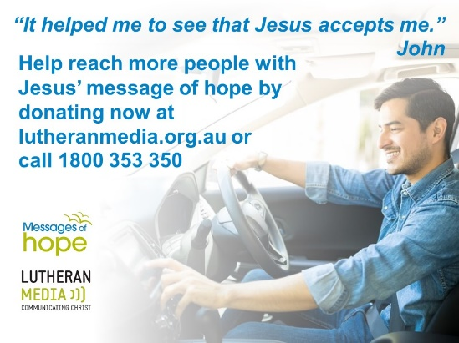
Do you have someone in your life who you would love to believe in Jesus Christ as their Lord and Saviour? Maybe a family member, friend or neighbour? Lutheran Media is partnering with you to reach them.
“The message on relationships grabbed me. It was great.” Tim
It was only 30 seconds but what a difference it made to Tim’s life. It helped him reconnect with his wife and children.
Producing and playing a 30 second Message of Hope costs $147 per message but has an eternal impact. I pray that you will join with us in raising $200,000 by the end of June to reach more people like Tim on more than 800 radio stations.You can do this by making a donation now at lutheranmedia.org.au/donate or call us in the office on (08) 8267 7314.

SHORT MOVIE COMPETITION


Do you like making short movies? Or know someone who does?
Enter the Lutheran Media Short Movie Competition with a movie under 4 minutes long that shares a story or theme of Christmas or Easter. Enter as an individual or as a group.
The best videos to be shared through social media and the internet.
Cash prizes for the best short movies and entries receive a Lutheran Media gift pack.
Entries close on the 10th September 2019.
Go to www.lutheranmedia.org.au/competition for more information and entry details.


What’s happening on our YouTube channel

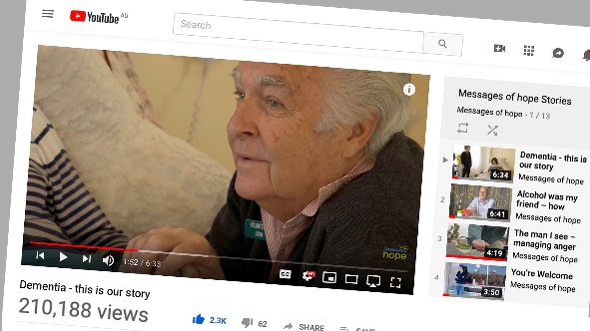
Four years ago we made a video story about John and Maureen and their journey with Maureen’s dementia. It has had over 220 000 views and responses. People were moved by not only their story, but John’s love, loyalty and faith. We revisited John a couple of months ago and John shared with us an update on his journey with Maureen, his incredible commitment to his wife and what gives him hope.

Check out the latest inspiring videos on our YouTube. There are 1 minute messages that you can download and play before or after your services www.youtube.com/messagesofhope

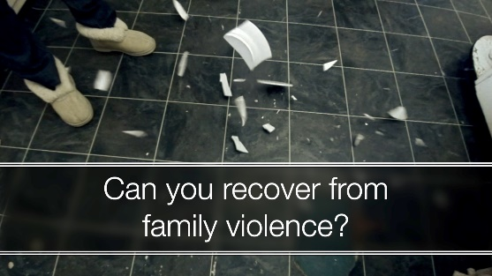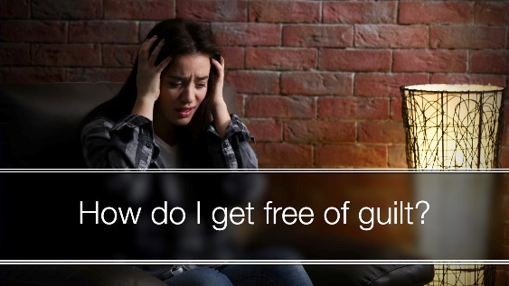

JOIN OUR FACEBOOK COMMUNITY AT:
www.facebook.com/messageshope
www.facebook.com/lutheranmedia
www.facebook.com/happyland4kids
www.facebook.com/messagesofhopenz
 Follow us on Twitter at @lutheranmedia, @messagesofhope1 and @messagesofhopenz
 Follow us on Instagram @luthmedia, @messagesofhope1

FAMILY FUN AT HAPPYLAND.COM.AU
Enjoy the Happyland website game at www.happyland.com.au. Set up your own character, change them, and take them on an adventure. Go on to the App store and download the Happyland App for iphone and ipad.
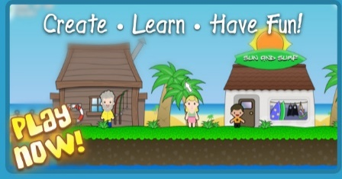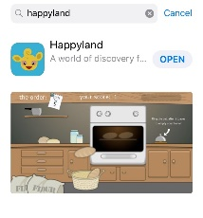
ONLINE LIVE STREAMED WORSHIP
Worship with the St Michael’s Lutheran Church, Hahndorf, SA or Good Shepherd Lutheran Church, Toowoomba, Qld at www.livestream.com/luthworship
FREE WORSHIP SERVICE DVDs
Can’t attend church? Order your FREE worship DVD/CD by contacting Lutheran Media. FREECALL 1800 353 350 or email us luthmedia@lca.org.au

