

Hi from the Lutheran Media Team. Thanks for your support. Please use whatever information you like below in your bulletins and newsletters, or even on your PowerPoint information slides at the start or end of service.

Listen to Messages of Hope and invite others to do the same. Download or listen online at www.messagesofhope.org.au, (www.messagesofhope.org.nz for New Zealand audiences).

5th August Gone Home (Interview)
Death is not a topic that we tend to talk about over a BBQ. Most of us don’t talk about death until it’s on our doorstep. Join Celia and Richard as they talk with Jonathan Krause about why we don’t need to be afraid to have those conversations.

12th August Connected (Pastor John Henderson)
Do you sometimes look at the people around you and think “I wish I could be like them?” It can cause us to focus on what we don’t do, and don’t have, and that can make us feel lonely, even if we’re surrounded by people who love us. This week John Henderson talks about loneliness, and how it’s cure can lie outside ourselves.

19th August All Alone (Pastor James Winderlich)
“I think that all of us move into and out of loneliness. Some people tragically find themselves all alone. None of us were meant for that.” Loneliness isn’t a feeling restricted to people who are single. It can affect anyone. Listen this week to James Winderlich talk about how we can feel alone and unconnected, even when we’re surrounded by people.

26th August Families Are Like Fudge (Pastor Rob Schubert)
“Families are like fudge. Mostly sweet, with a few nuts!” All families struggle with trying to balance individual needs and the family as a whole. Join us this week as Rob Schubert points out that even in the Bible there are no perfect families. Yet God does great things through them. Perhaps God can work in your family too.

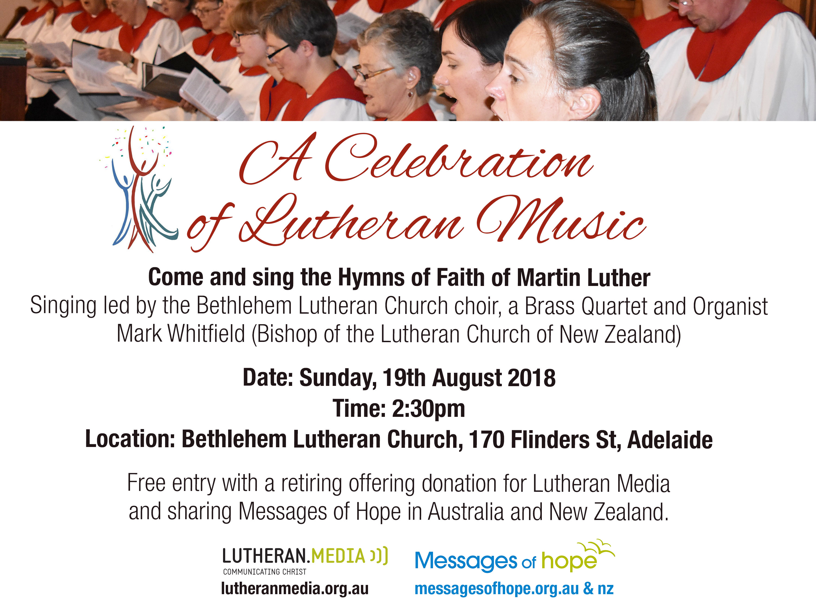

HAPPYLAND APP
All your favourite games from the website and more are available now on your iphones and ipads! Available o download from the App store, search for “Happyland” or “Lutheran Media”. More games and an android version to come.

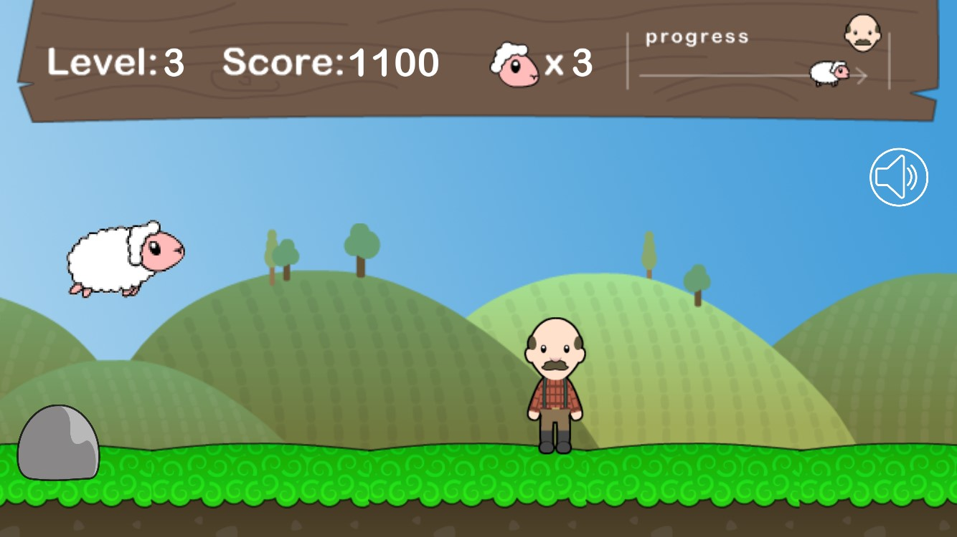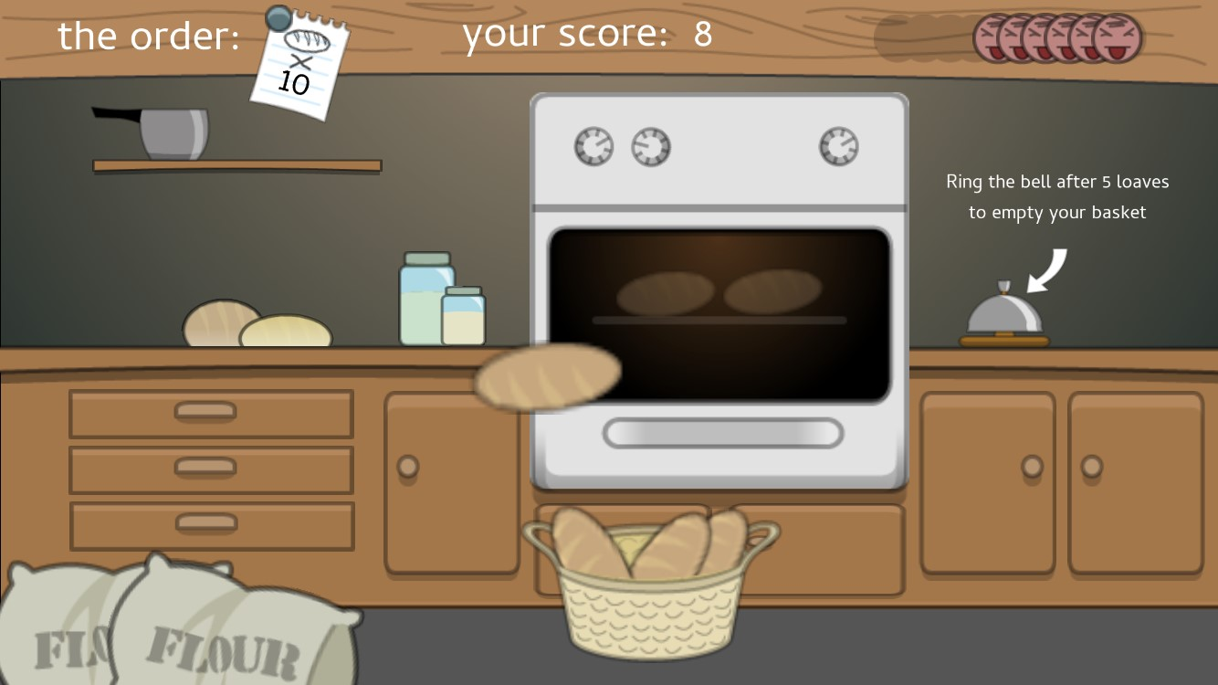



Short Movie Competition
Just a reminder – it’s not too late to make your own movie!!
Enter the Lutheran Media Short Movie Competition with a movie under 4 minutes long that shares a story of Christian hope or your favourite bible story in your own style.
Enter as an individual or as a group. The best videos to be shown at the LCA Convention of Synod in October 2018 and shared through social media and the internet. Cash prizes for the best short movies and entries receive a Lutheran Media gift pack. Entries close on the 11th September 2018.
Go to www.lutheranmedia.org.au/competition for more information and entry details.

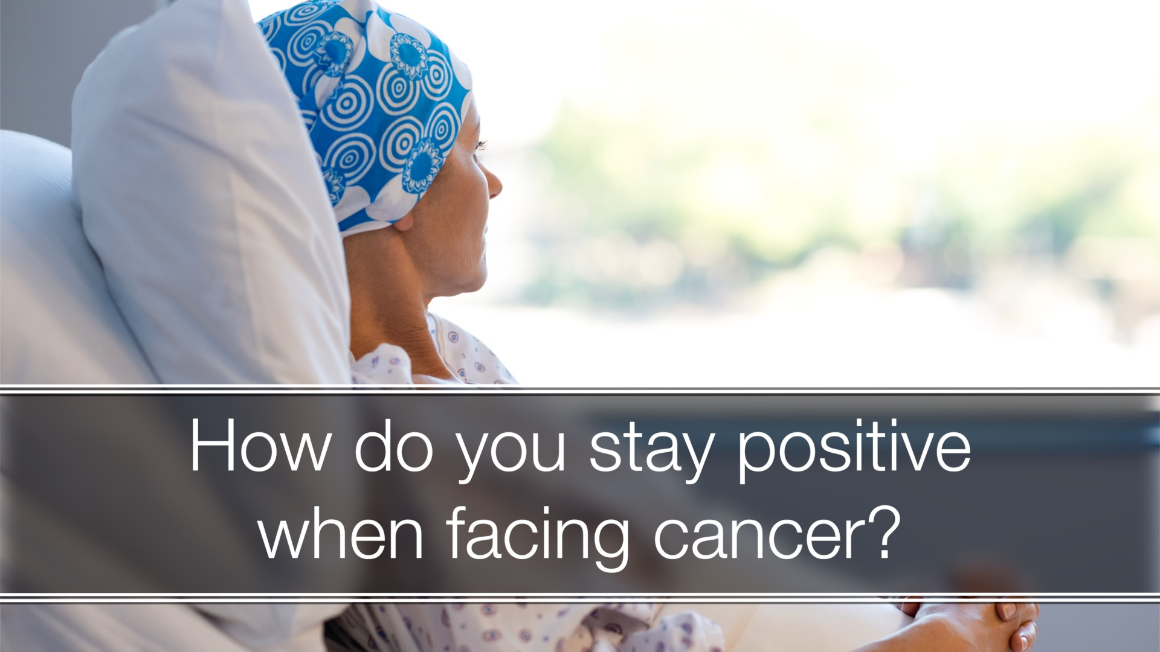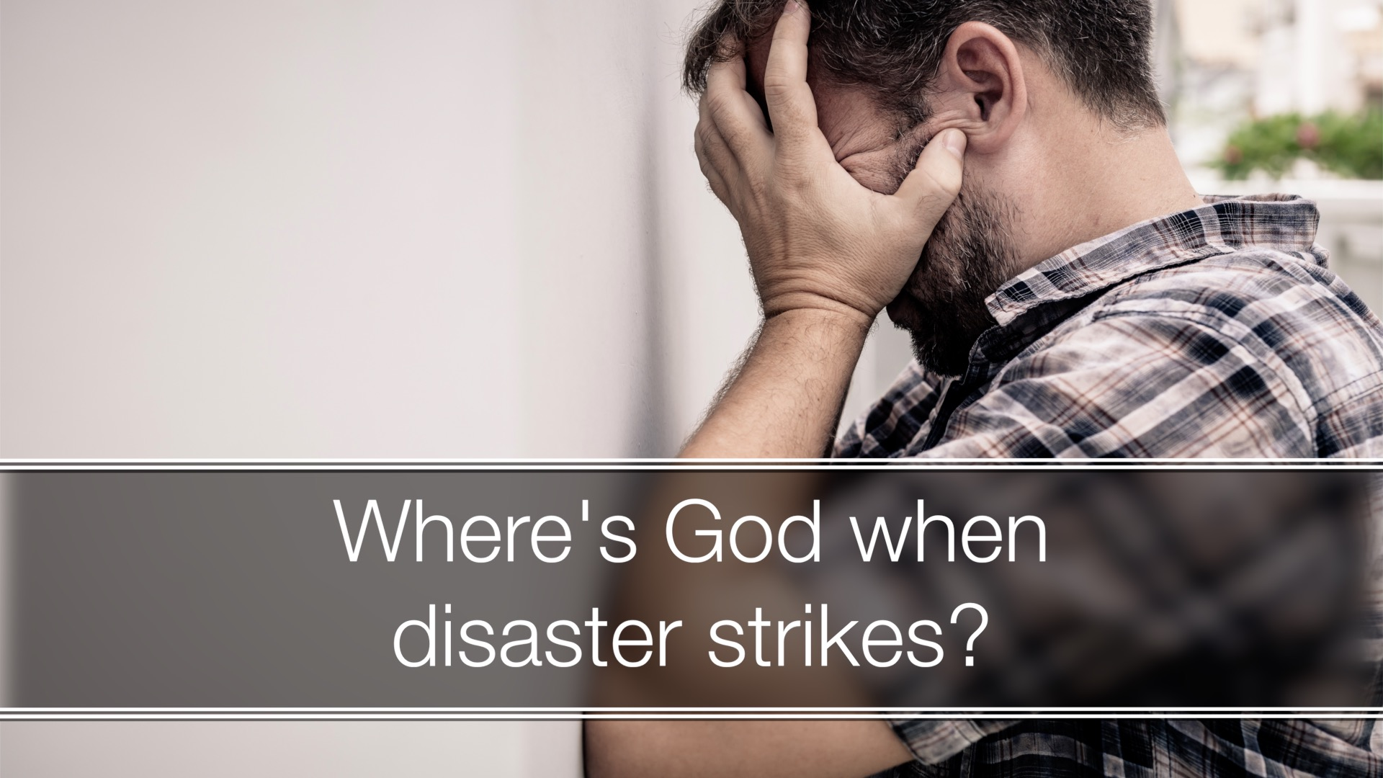

Check out the latest inspiring videos on our Messages of Hope Australia and New Zealand websites www.youtube.com/messagesofhope and www.messagesofhope.org.nz . Have a look at what our ministry and mission is doing. You can download and play these before or after your services. The New Zealand ones are only 30 seconds long and the Australian ones are 60 seconds

JOIN OUR FACEBOOK COMMUNITY AT:
www.facebook.com/messageshope
www.facebook.com/lutheranmedia
www.facebook.com/happyland4kids
www.facebook.com/messagesofhopenz
 Follow us on Twitter at @lutheranmedia, @messagesofhope1 and @messagesofhopenz
 Follow us on Instagram @luthmedia, @messagesofhope1
FAMILY FUN AT HAPPYLAND.COM.AU
Enjoy the Happyland website game at www.happyland.com.au. Set up your own character, change them, and take them on an adventure. Check out the happyland App from the App store too.

ONLINE LIVE STREAMED WORSHIP
Worship with the St Michael’s Lutheran Church, Hahndorf, SA or Good Shepherd Lutheran Church, Toowoomba, Qld at www.livestream.com/luthworship
FREE WORSHIP SERVICE DVDs
Can’t attend church? Order your FREE worship DVD/CD by contacting Lutheran Media. FREECALL 1800 353 350 or luthmedia@lca.org.au

