

Hi from the Lutheran Media Team. Thanks for your support. Please use whatever information you like below in your bulletins and newsletters, or even on your PowerPoint information slides at the start or end of service.

Listen to Messages of Hope and invite others to do the same. Download or listen online at www.messagesof hope.org.au, (www.messagesofhope.org.nz for New Zealand audiences).



5th November Karl’s Dark Secret (Pastor Richard Fox)
Do you ever feel guilty? Trying to be free of guilt can be difficult. Especially when it’s from a deep dark secret. Listen in as Richard shares the story of Karl who seemed to have the perfect life, but was also trying to run away from a dark secret. How did he find freedom from his guilt?

12th November Why Did I do it? (Interview with Richard and Celia)
We’ve all experienced times when one innocent thing led to another and suddenly things are a bit out of control and we’re caught out, embarrassed and wish we could crawl under a rock somewhere. Join us as Jonathan Krause shares a humorous story from his new book “Come to Life”

19th November Hot and Thirsty (Pastor Noel Due)
Do you have a past that you want to forget? We may try to ignore it by covering the pain with alcohol, drugs, relationships or some other escape – but the guilt and shame sticks around. Listen in as Noel shares some stories that will give you hope and a way to find peace

26th November Waiting on God (Interview)
Are there times when you’ve felt down and despondent – where you were desperate for encouragement? Join us as Robyn shares how she’s coped with life’s ups and downs, especially when dealing with a son with a drug addiction.

Short Movie Competition


Watch the short movies that were entered into the Lutheran Media Short Movie Competition at www.lutheranmedia.org.au/competition and at www.youtube.com/messagesofhope Short Movie Competition playlist. There are fun and engaging bible story re-enactments and stories of hope.

A Man Named Martin – 3 Part DVD series
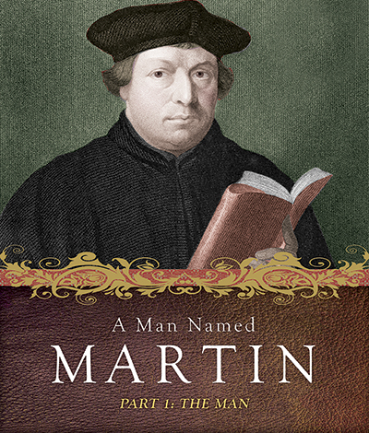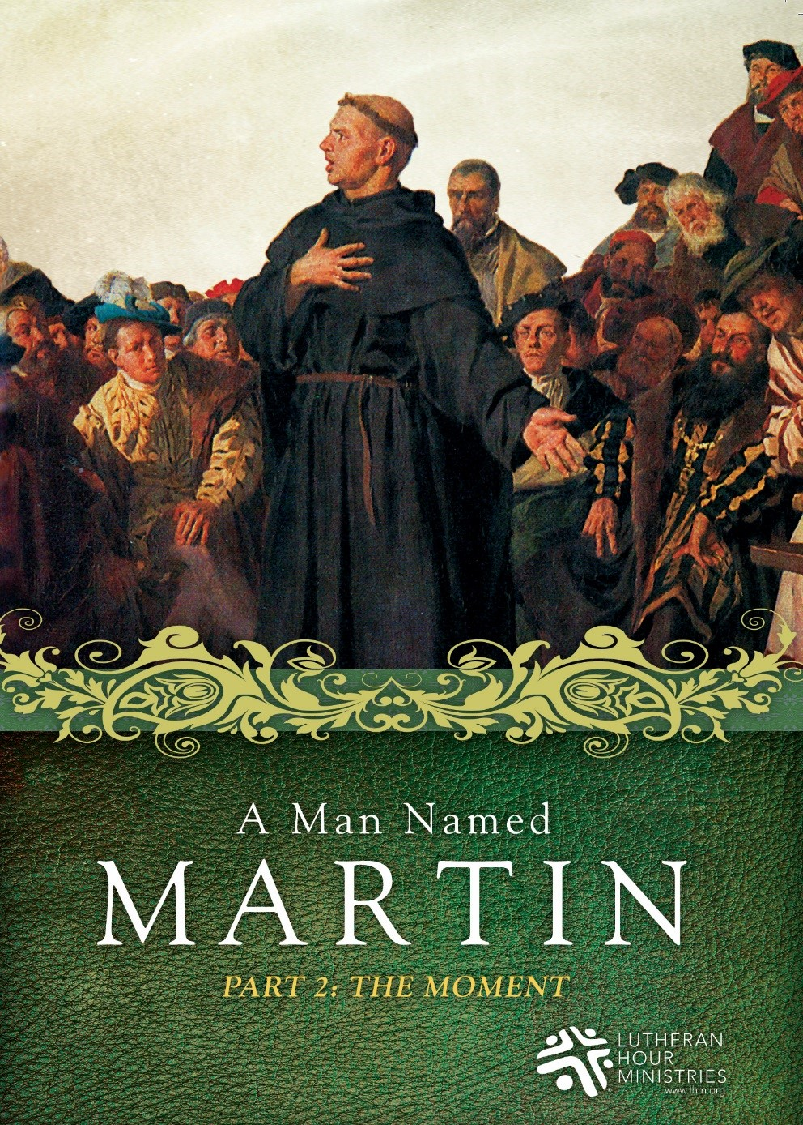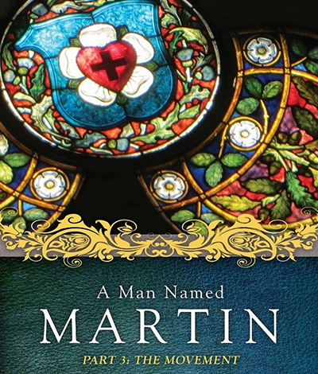
Have you ever wondered who Martin Luther was, or why we needed a reformation, or how it shapes the world we live in today? Order and watch the 3 Part DVD series to learn more about Martin Luther and the Reformation at lutheranmedia.org.au/luther

.
Check out the latest inspiring videos at www.youtube.com/messagesofhope
JOIN OUR FACEBOOK COMMUNITY AT:
www.facebook.com/messageshope
www.facebook.com/lutheranmedia
www.facebook.com/happyland4kids
www.facebook.com/messagesofhopenz
 Follow us on Twitter at @lutheranmedia, @messagesofhope1 and @messagesofhopenz
 Follow us on Instagram @luthmedia, @messagesofhope1
FAMILY FUN AT HAPPYLAND.COM.AU
Enjoy the Happyland website game at www.happyland.com.au. Set up your own character, change them, and take them on an adventure.
Stay tuned for the new happyland app that will be launched soon.


ONLINE LIVE STREAMED WORSHIP
Worship with the St Michael’s Lutheran Church at Hahndorf in SA at livestream.com/luthworship
FREE WORSHIP SERVICE DVDs
Can’t attend church? Order your FREE worship DVD/CD by contacting Lutheran Media. FREECALL 1800 353 350 or luthmedia@lca.org.au

