

Hi from the Lutheran Media Team. Thanks for your support. Please use whatever information you like below in your bulletins and newsletters, or even on your PowerPoint information slides at the start or end of service.

Listen to Messages of Hope and invite others to do the same. Download or listen online at www.messagesof hope.org.au, (www.messagesofhope.org.nz for New Zealand audiences).



1st October Endless Love (Pastor Noel Due)
Do you feel like your future is looking bleak? When times are tough it’s hard to see the way ahead. Listen in as Noel tells the story of Geoff who struggled to survive in the Japanese prisoner of war camps and what helped to get him through.

18th October Smashing Plates – part 1 (Interview)
Have you ever felt like smashing something? Overcoming feelings of anger, frustration, and helplessness can sometimes seem impossible. Listen in to hear one woman’s journey of healing from a childhood trauma.

15th October Smashing Plates – part 2 (Interview)
Are you struggling to clear your mind of something from the past? Join us for the second part of this program where Chris shares one of the key things that helped free her from the trauma of her past.

22nd October Unexpected (Interview)
Have you ever experienced a sudden event which threw you for six and left you wondering why? Join us as we talk to Bishop John Henderson and try to make sense of why bad things happen.

29th October Good enough (Pastor Richard Fox)
Do you ever ask yourself “Am I good enough?” Trying to measure up to family and friends, your boss or even yourself can be difficult. Listen in to Richard as he shares some good news for those of us who never quite feel we are good enough.

Booklet Offer for October programs
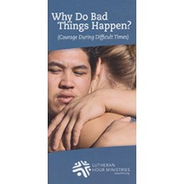
Have you ever wondered where God is when life suddenly takes a turn for the worse? Author and pastor, Dr Philip Bickel shares why trouble exists in the world, the benefit that can come out of suffering and what God has done to deal with the evil and pain of this world. He also reminds us of God’s unconditional love for his people. For a free copy of Why Do Bad Things Happen? or any of our resources visit our website, http://www.lutheranmedia.org.au/our-ministries/booklets

A Man Named Martin - Part 3: The Movement
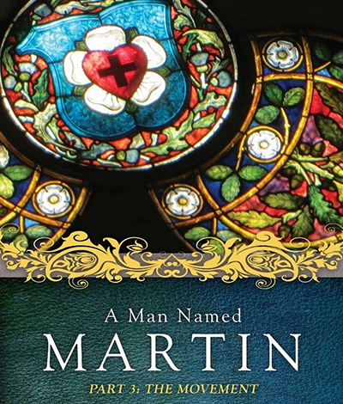
A Man Named Martin - Part 3: The Movement is the final part following A Man Named Martin-Part 1:The Man and A Man Named Martin-Part 2:The Moment. Watch the third and final part in the series about how the Reformation influenced Europe and the world as we know it today. There are 5 videos and a discussion guide.

.
Check out the latest inspiring videos at www.youtube.com/messagesofhope
JOIN OUR FACEBOOK COMMUNITY AT:
www.facebook.com/messageshope
www.facebook.com/lutheranmedia
www.facebook.com/happyland4kids
www.facebook.com/messagesofhopenz
 Follow us on Twitter at @lutheranmedia, @messagesofhope1 and @messagesofhopenz
 Follow us on Instagram @luthmedia, @messagesofhope1
FAMILY FUN AT HAPPYLAND.COM.AU
Enjoy the Happyland website game at www.happyland.com.au. Set up your own character, change them, and take them on an adventure.
Stay tuned for the new happyland app that will be launched soon.


ONLINE LIVE STREAMED WORSHIP
Worship with the St Michael’s Lutheran Church at Hahndorf in SA at livestream.com/luthworship
FREE WORSHIP SERVICE DVDs
Can’t attend church? Order your FREE worship DVD/CD by contacting Lutheran Media. FREECALL 1800 353 350 or luthmedia@lca.org.au

