

Hi from the Lutheran Media Team. Thanks for your support. Please use whatever information you like below in your bulletins and newsletters.

Listen to Messages of Hope and invite others to do the same. Download or listen online at www.messagesof hope.org.au, (www.messagesofhope.org.nz for New Zealand audiences).

SHORT MOVIE COMPETITION


Don’t forget to get your entries in for the Lutheran Media Short Movie Competition. The best videos will to be shown at premier events in October 2017 and shared through social media and the internet. Cash prizes for the best short movies and entries receive a Lutheran Media gift pack. Entries close on the 11th September 2017.
For more information go to www.lutheranmedia.org.au/competition or call Lutheran Media on 1800 353 350.


3rd September Fathers Richard and Celia
Being a dad isn’t always easy, and it’s good to know we’re not the only ones that might muck up at times. Listen in to hear a group of dads share their joys, struggles and hopes, and be encouraged in your own journey as a dad.

10th September Defending Territory (Interview)
How do you bring two families together into a new family unit? Tune in to hear how Mark and Beth blended their families’ different parenting styles and disciplines, and what it took to make the relationships work.

17th September I Remember When… (Pastor Richard Fox)
“I remember when” You may have heard or used this phrase. But what happens when we can’t remember? Listen into to Richard as he shares his journey with his grandpa.

24th September Dementia is not the end (Interview)
Do you struggle to understand and relate with a loved one who has dementia? Listen in as Celia talks with Gaye, who has worked in aged care for over 20 years, about some of the misunderstandings of and insights to living with dementia

Booklet Offer for September programs


Are you wondering if there is any fun in being a parent? In one of our most recent resources, Julie Hahn, mother of four grown up children, has experienced many ups and downs as a parent. She empathises as a non-perfect parent herself and offers her insights and encouragement to inspire you as a parent in Parenting – Finding the Fun. For a free copy of this, or any of our resources visit our website, http://www.lutheranmedia.org.au/our-ministries/booklets

A Man Named Martin - Part 3: The Movement
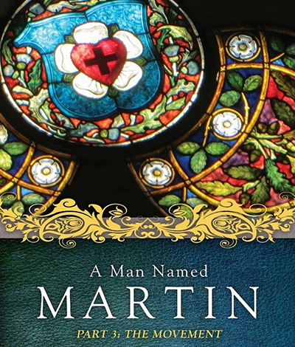
A Man Named Martin - Part 3: The Movement is the final part following A Man Named Martin-Part 1:The Man and A Man Named Martin-Part 2:The Moment. Watch the third and final part in the series about how the Reformation influenced Europe and the world as we know it today. There are 5 videos and a discussion guide.

.
Check out the latest inspiring videos at www.youtube.com/messagesofhope
JOIN OUR FACEBOOK COMMUNITY AT:
www.facebook.com/messageshope
www.facebook.com/lutheranmedia
www.facebook.com/happyland4kids
www.facebook.com/messagesofhopenz
 Follow us on Twitter at @lutheranmedia, @messagesofhope1 and @messagesofhopenz
 Follow us on Instagram @luthmedia, @messagesofhope1
FAMILY FUN AT HAPPYLAND.COM.AU
Enjoy the Happyland website game at www.happyland.com.au. Set up your own character, change them, and take them on an adventure.
Stay tuned for the new happyland app that will be launched soon.


ONLINE LIVE STREAMED WORSHIP
Worship with the St Michael’s Lutheran Church at Hahndorf in SA at livestream.com/luthworship
FREE WORSHIP SERVICE DVDs
Can’t attend church? Order your FREE worship DVD/CD by contacting Lutheran Media. FREECALL 1800 353 350 or luthmedia@lca.org.au

