

Happy New Year! Jesus Christ inspire and guide you with his hope in 2017.
Thanks for your support. Please use whatever information you like below in your bulletins and newsletters.

Face to Face changing to Messages of hope
Face to Face is changing to Messages of hope due to people searching for real hope, the hope that Jesus offers. You can watch inspiring messages of hope in Jesus Christ, order free booklets of hope and share these with a friend in need. Go to www.messagesofhope.org.au (www.messagesofhope.org.nz for New Zealand audiences). We’d love to get your responses and feedback to the changes.


Listen to Messages of Hope and invite others to do the same. Download or listen online at www.messagesof hope.org.au, including on your mobile internet devices.

5th February A Second Chance (Interview)
Family relationships don’t always work out the way we’d like them to but it doesn’t necessarily mean giving up. This week we’ll be talking with Gavin and Dion whose story shows it’s never too late for a second chance.

12th February Love That Lasts (Pastor Trevor Keller)
Do you feel loved? Maybe you’ve lost that spark but would like to get it back? Join us this week when we talk about love that lasts.
19th February Am I Too Old? (Pastor Rob Schubert)
How do you feel about getting older? In a culture that values youth, age can easily be devalued. We see age as a loss of youth rather than a gaining of life experience. Rob Schubert will share some good news for those of us who are worrying about our age.

26th February Early Onset Dementia (Interview)
How do you face the future when you feel like you’re losing your past? Listen in this week to hear how Ann is adjusting to early onset Dementia.

2017 SCRIPTURE CALENDAR
There are still a few copies available of the popular calendar for you to order and share.
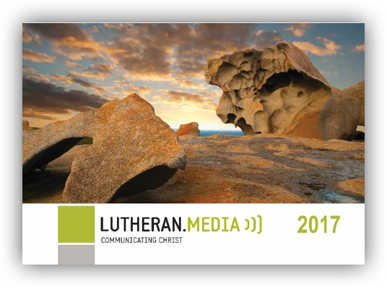
It’s ideal for your home, office, and shed and includes;
• inspirational pictures and bible verses
• large open date boxes for you to write in
• public holidays, moon cycles, and school terms
Order your 2017 Scripture Calendar by following the links from lutheranmedia.org.au or FREECALL 1800 353 350.


www.youtube.com/luthmedia (check out the channels link for more short videos)

Like, share or make a comment on Facebook at;
www.facebook.com/messageshope
www.facebook.com/lutheranmediaministry
www.facebook.com/happyland4kids
www.facebook.com/messagesofhopenz
Follow us on Twitter at @lutheranmedia, @messagesofhope1 and @messagesofhopenz
 Follow us on Instagram @luthmedia
FAMILY FUN AT HAPPYLAND.COM.AU
Enjoy the Happyland website game at www.happyland.com.au. Set up your own character, change them, and take them on an adventure.


FREE ONLINE DAILY DEVOTIONS
Enter your email address at the Daily Devotion link on www.lca.org.au to subscribe and we will email you a free devotion every day.
ONLINE LIVE STREAMED WORSHIP
Worship with the St Michael’s Lutheran Church at Hahndorf in SA at livestream.com/luthworship
FREE WORSHIP SERVICE DVDs
Can’t attend church? Order your FREE worship DVD/CD by contacting Lutheran Media. FREECALL 1800 353 350 or luthmedia@lca.org.au

