

Thanks for your support. Please use whatever information you like below in your bulletins and newsletters.
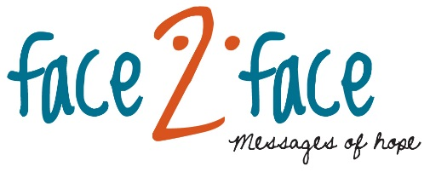
Listen to FACE TO FACE and invite others to do the same. Download or listen online at www.facetoface.org.au, including on your mobile internet devices.
1st May Are you afraid? (Round Table)
If we can’t escape fear, how do we stop it controlling our lives?
8th May Stoned (Pastor Noel Due)
Stoning has been around for centuries and is sadly still practiced today. How did Jesus react to this practise of punishment?
15th May Domestic Violence (Interview)
Phrases like ‘for better for worse’, ‘in sickness and in health’, ‘till death do us part’ are common in wedding ceremonies. But what relevance do these promises have when a relationship turns abusive?
22nd May Emotional Abuse (Interview)
When hear about abuse we often think of physical violence but Barbara will talk about a more subtle and equally devastating form of abuse. Hear how family and friends can help victims of domestic violence.
29th May Rage (Pastor Richard Fox)
Tailgating, rude gestures, and shouting and banging on windows are some of the examples of road rage. How do you deal with road rage?
New For Men Website
A new outreach website at www.facetoface.org.au/for-men has been launched. You’ll find videos, booklets, and new small group discussion videos and guides to download and enjoy. Share it with your mates.
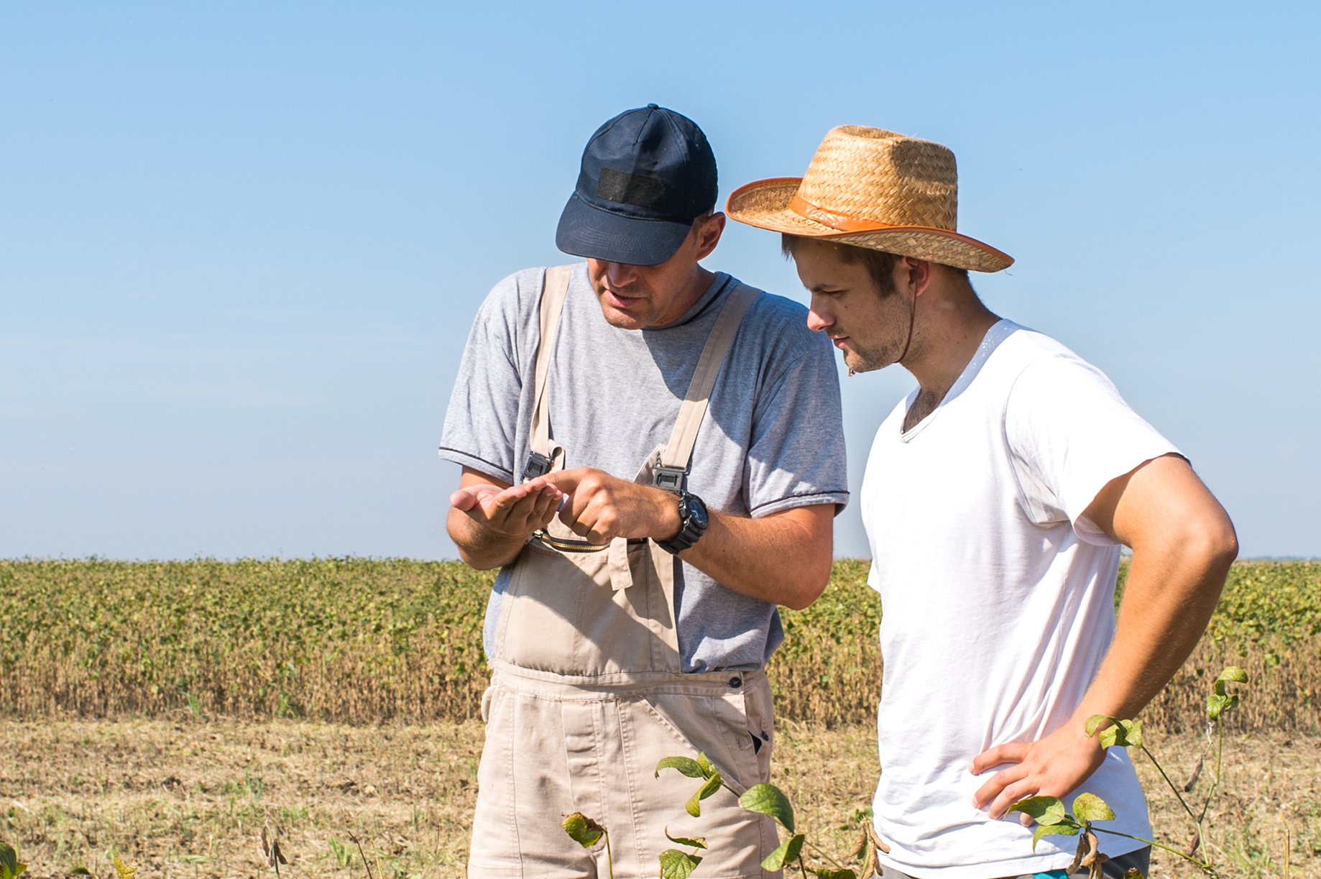
Martin Luther DVD
Ever wondered who Martin Luther was? In light of the 500 year anniversary of the reformation, the first of 3 DVDs is available about Martin Luther: The Man. It contains a 5 session video and discussion guide and goes through the details of Luther’s life. Watch and download the videos for free or order the DVD version that comes with a printed discussion guide for $15 at www.lutheranmedia.org.au/luther. Or call us on 1800 353 350. You can order more printed discussion guides too for $2 each.
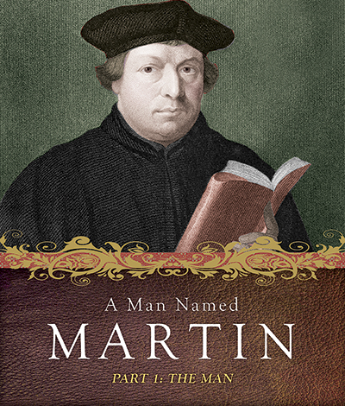

www.youtube.com/luthmedia (check out the channels link for more short videos)

Like, share or make a comment on Facebook at;
www.facebook.com/facetofaceradio
www.facebook.com/lutheranmediaministry
www.facebook.com/happyland4kids
Follow us on Twitter at @lutheranmedia and @facetofacelm
FAMILY FUN AT HAPPYLAND.COM.AU
Enjoy the Happyland website game at www.happyland.com.au. Set up your own character, change them, and take them on an adventure.

FREE ONLINE DAILY DEVOTIONS
Enter your email address at the Daily Devotion link on www.lca.org.au to subscribe and we will email you a free devotion every day.
ONLINE LIVE STREAMED WORSHIP
Worship with the St Michael’s Lutheran Church at Hahndorf in SA at livestream.com/luthworship
FREE WORSHIP SERVICE DVDs
Can’t attend church? Order your FREE worship DVD/CD by contacting Lutheran Media. FREECALL 1800 353 350 or luthmedia@lca.org.au

