

Thanks for your support. Please use whatever information you like below in your bulletins and newsletters.

COMING SOON: Dementia – searching for hope
Join us for a series of short stories and resources on Dementia – Searching for Hope.
More than 300,000 people were diagnosed with dementia last year and is the second leading cause of death. Where is God in all of this and where is hope?
Dementia – Searching for Hope is coming soon to www.facetoface.org.au. There’ll be hope filled stories and a message that God remembers us, even when we can’t.

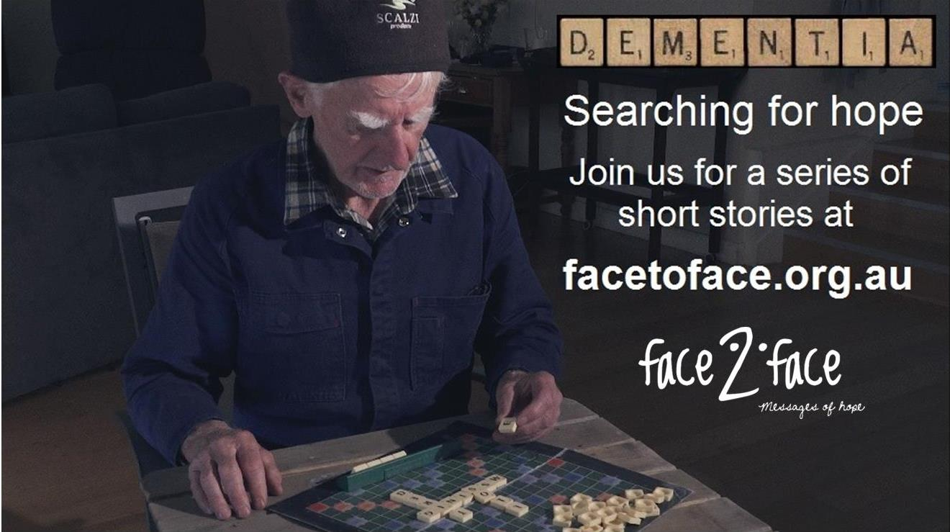

Happy Birthday!
On the 2nd September 1945 the Lutheran Hour was aired on radio for the first time. Dr Walter Maier was heard on 36 radio stations and 106 people responded by mail. 45 pounds were received as a donation. Bringing Christ to the nations and the nations to Christ.


Listen to FACE TO FACE and invite others to do the same. Download or listen online at www.facetoface.org.au, including on your mobile internet devices.
4th October God goes before us (Interview)
“I used to be able to walk into a room and engage with anybody, now I walk into a room and I don't want to engage with anybody.” We continue our interview with Ann who has early onset Demetia. We talk about the struggles to communicate and be understood, and how Ann and her husband Timothy approach the future, knowing the disease will worsen as time passes.
11th October Freedom (Pastor Richard Fox)
Have you ever wondered what it would be like to be truly free? You may have heard of people being rescued from mines, or hostages set free. But what about living in the freedom from things like guilt and fear?
18th October Being carried (Pastor Noel Due)
“Trust is nothing other than resting back, letting someone else take the strain. It’s not trying to carry yourself, it’s being carried.” Noel Due reflects on the sense of security he had as a child, being carried in the arms of his dad. Do you remember a time when you could trust someone enough to relax in their arms.
25th October Leg Less (Interview)
“I love going for walks but when I walked down to the beachfront that morning I had no idea that I was going to lose my legs.” How would you cope if you suddenly lost both your legs? Dean talks about his near death encounter with the flesh eating infection Necrotizing Fasciitis (Fash-ee-itis). After almost 3 months in a coma he survived to discover that both his legs had been amputated. How is he coping 3 years on?

Like, share or make a comment on Facebook at;
www.facebook.com/facetofaceradio
www.facebook.com/lutheranmediaministry
www.facebook.com/happyland4kids
Follow us on Twitter at @lutheranmedia and @facetofacelm
FAMILY FUN AT HAPPYLAND.COM.AU
Enjoy the Happyland website game at www.happyland.com.au. Set up your own character, change them, and take them on an adventure.

Buy your Happyland Stories DVD for $10. 5 short and engaging videos and colouring-in pages. They make great gifts.

FREE ONLINE DAILY DEVOTIONS
Enter your email address at the Daily Devotion link on www.lutheranmedia.org.au to subscribe and we will email you a free devotion every day.
ONLINE LIVE STREAMED WORSHIP
Worship with the St Michael’s Lutheran Church at Hahndorf in SA at new.livestream.com/luthworship
FREE WORSHIP SERVICE DVDs
Can’t attend church? Order your FREE worship DVD/CD by contacting Lutheran Media. FREECALL 1800 353 350 or luthmedia@lca.org.au
TELEVISION
ON MAIN STREET, a half hour talk show discussing socially relevant issues. 11:30pm Saturday (AEST) on the Australian Christian Channel AUSTAR DIGITAL 182, FOXTEL DIGITAL 182, OPTUS 49 / Digital 182, TRANSACT (Canberra). Go to www.onmainstreet.org.au for more information.

