

Thanks for your support. Please use whatever information you like below in your bulletins and newsletters.
FACE TO FACE GREETING CARDS
Face to Face offers you Greeting cards to use for birthdays, sympathy, get well or to simply say hello. There are 5 different designs in a pack and contain a hope filled bible verse. Order your pack/s for $5 each plus $2 postage and handling at www.lutheranmedia.org.au or phone FREECALL 1800 353 350.

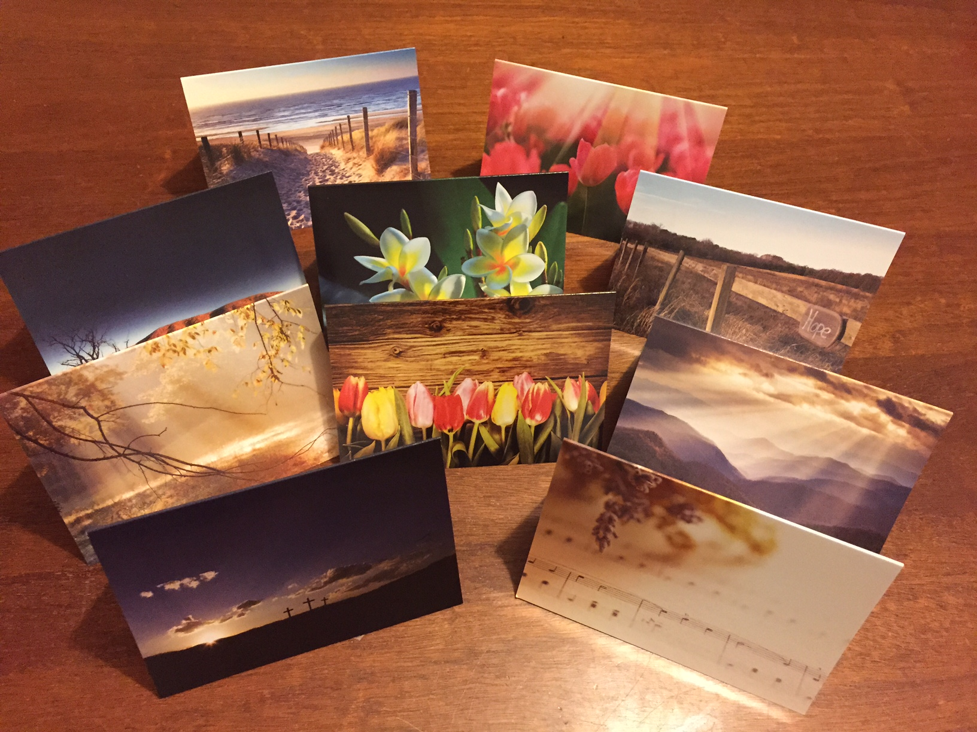
ENEWS
Don’t miss out! Keep up to date with the latest offers, Face to Face messages, and news from Lutheran Media. Subscribe with your email address to the Lutheran Media Outreach eNews. Click on the “News” link on the www.lutheranmedia.org.au homepage.
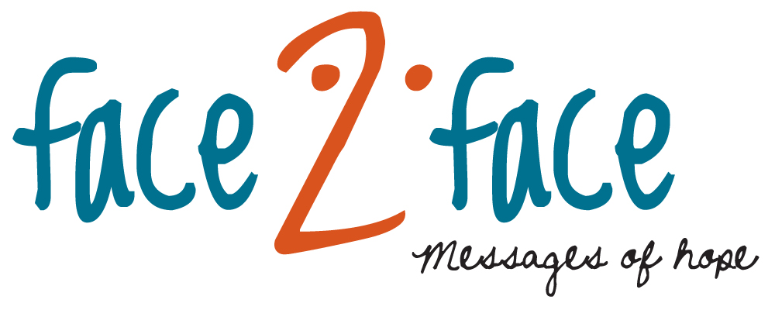
Listen to FACE TO FACE and invite others to do the same. Download or listen online at www.facetoface.org.au, including on your mobile internet devices.
7th June Doing things that last (Mark Doecke)
A survey of people over the age of 80 asked, “what would you do differently, if you had another chance at life?” One of the most popular responses was, “I’d do things that last.” How would you respond to that question? Principal Mark Doecke believes there are things that last and we can be part of them.
14th June Lost in a black hole (Noel Due)
Have you ever felt trapped in your own thoughts and feelings, regrets and failings? It can be a lonely place. It can feel like your sinking in a black hole with no way out. Noel Due wants to encourage you that there is a way out.
21st June Running the race (Richard Fox)
In the 400 metres semi-final of the ‘92 Olympic Games, a runner tore his hamstring and fell to the ground in agony with 250 metres left to run. Everyone thought that his race was over. Have you ever faced a challenge that pushed you to the limit? Join Richard Fox to hear how we can get to the finish line.
28th June A ladder in your pocket (Noel Due)
“I didn’t find any real connection between what was said in church with what happened in the rest of life. And there at college I met a couple of people who blew all of my experiences and theories about church and God and Jesus completely out of the water. Listen in to hear how Noel turned from religious cynic to Jesus believer.
 Like, share or make a comment on Facebook at www.facebook.com/facetofaceradio
FAMILY FUN AT HAPPYLAND.COM.AU
Enjoy the Happyland website game at www.happyland.com.au. Set up your own character, change them, and take them on an adventure.

Buy your Happyland Stories DVD for $10. 5 short and engaging videos and colouring-in pages. They make great gifts.
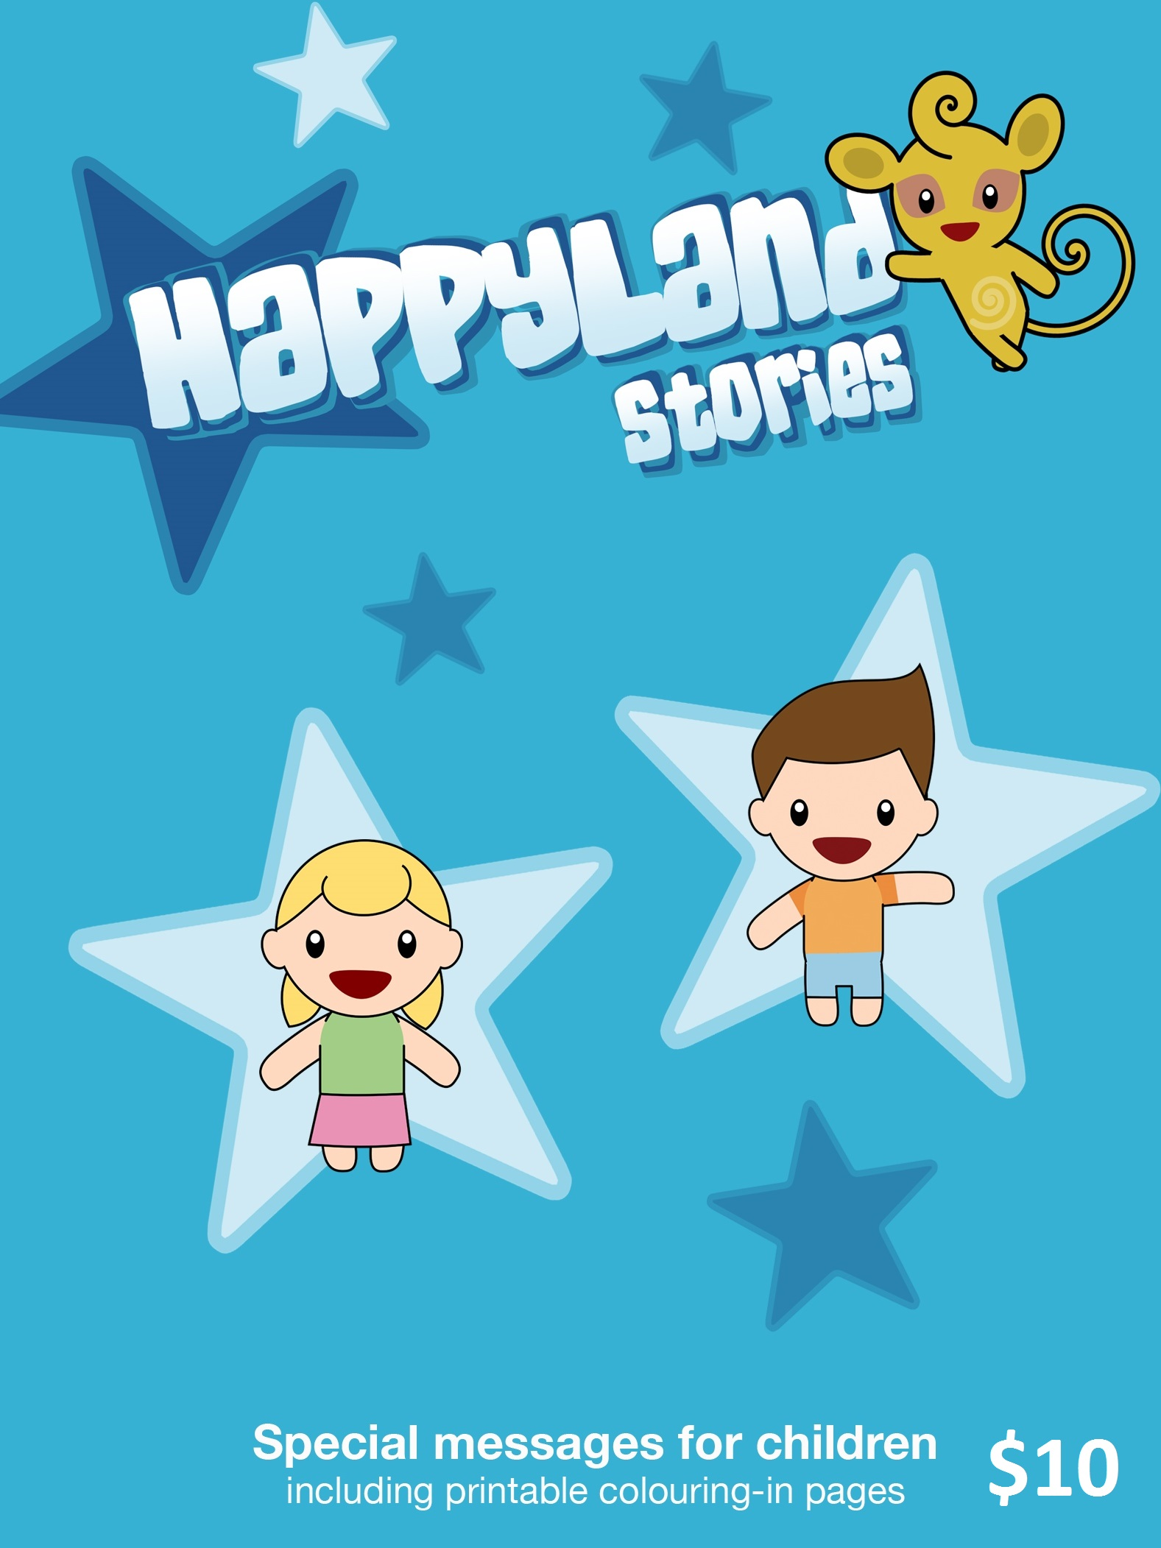
FREE ONLINE DAILY DEVOTIONS
Enter your email address at the Daily Devotion link on www.lutheranmedia.org.au to subscribe and we will email you a free devotion every day.
ONLINE LIVE STREAMED WORSHIP
Worship with the St Michael’s Lutheran Church at Hahndorf in SA at new.livestream.com/luthworship
FREE WORSHIP SERVICE DVDs
Can’t attend church? Order your FREE worship DVD/CD by contacting Lutheran Media. FREECALL 1800 353 350 or luthmedia@lca.org.au
TELEVISION
ON MAIN STREET, a half hour talk show discussing socially relevant issues. 11:30pm Saturday (AEST) on the Australian Christian Channel AUSTAR DIGITAL 182, FOXTEL DIGITAL 182, OPTUS 49 / Digital 182, TRANSACT (Canberra). Go to www.onmainstreet.org.au for more information.

